**SETUP MANUAL**

1. Download the project named Movie_Management.zip from courseweb.

2.Unzip the file.

3.Open Netbeans and select File option.

4.Under the File option select New project.

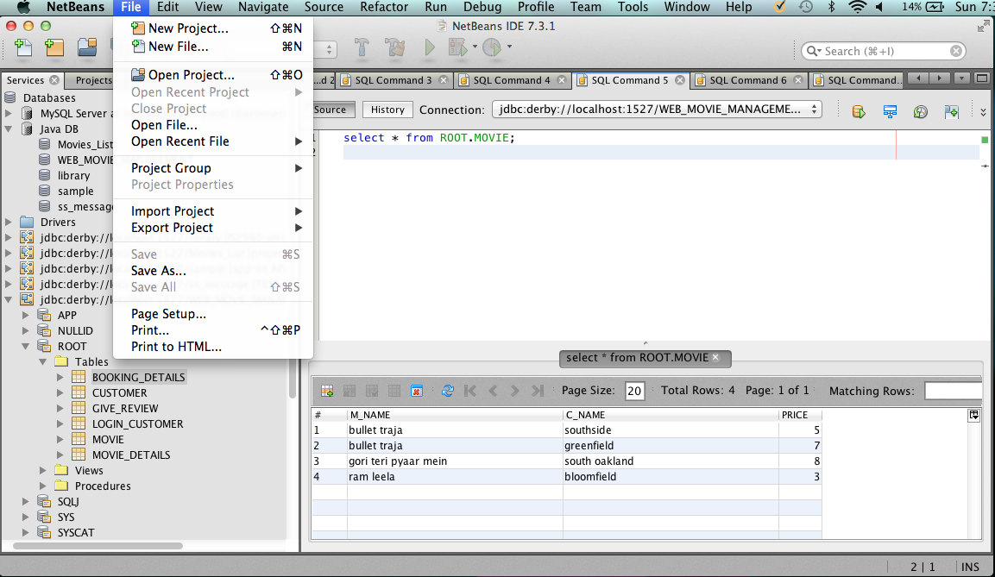

5. Select Java Web and then Java Web with Existing Sources.

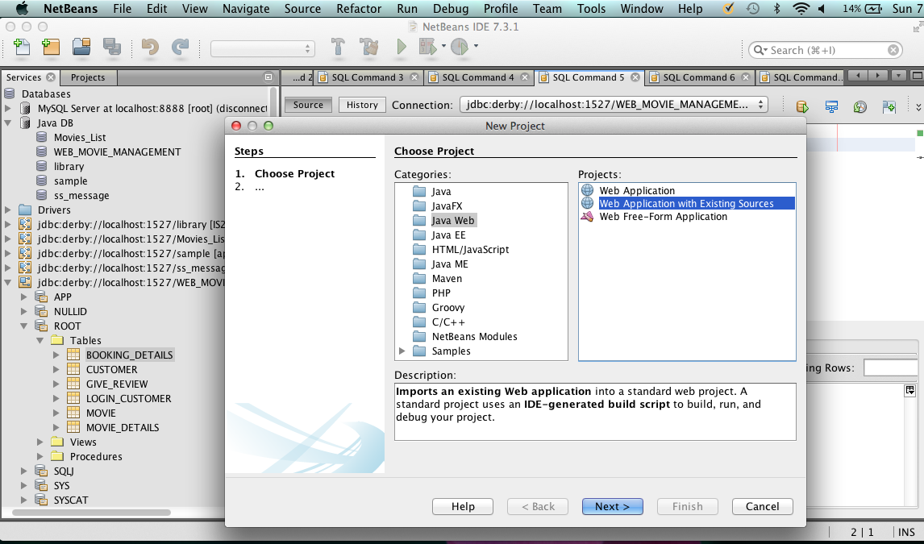

6, Click on next and the page below will appear on your screen. In the location field browse to the folder where the project is saved.

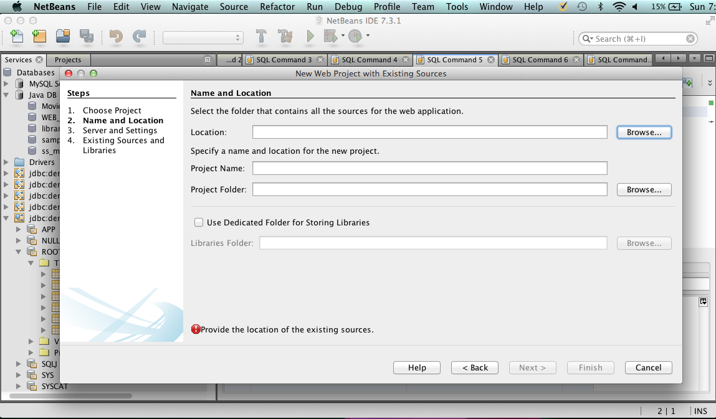

7. On entering the path details here then click on next and the new project is created.

8. For the database copy the folder Web_Movie Management into the .netbeans -derby folder where all the database for netbeans is stored. Then click on Services tab . Here select Database and then right click on Java DB. The Web_Movie_Mangement folder will appear . To connect to the database right lick on Java DB and select the option to Start Server. Then click on the folder mentioned in the image below for the database to be connected

Macintosh HD:Users:cheryldsouza:Desktop:Screen Shot 2013-12-09 at 5.08.16 AM.png